Example 1 - UAI 655

## Exam – oral part – summer 2017

|  |  |
| --- | --- |
| Name of student |  |
| Date |  |

# Affine cipher

The principle is

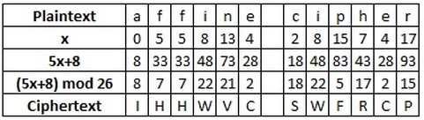

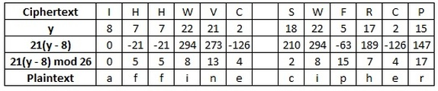

The text is

en_text = ‘FCAFLC ORA LWJC WV MLIUU RAEUCU URAELX VAZ ZRPAO UZAVCU. CVMLWUR FPAJCPN.’

Write a simple program in Python3 which decrypts the en_text and prints on the screen.

The program:

|  |
| --- |
|  |

The decrypted text:

|  |
| --- |
|  |